PROJECT PROPOSAL

Lesego Malesa
2026

TABLE OF CONTENTS

Organisation Overview..........................................................................................1

Website Goals and Objectives...............................................................................2

Proposed Website Features and Functionality.........................................................3

Design and User Experience...................................................................................4

Technical Requirements.........................................................................................5

Timeline and Milestones.........................................................................................6

Budget...................................................................................................................7

References.............................................................................................................8

Organisation Overview

Name and Slogan
SneakNova - Step Into What’s Next.

Brief History
SneakNova is a fictional South African sneaker retailer established in Johannesburg in 2026 by a group of sneaker enthusiasts. The business aims to provide customers with a convenient platform to explore fashionable and athletic footwear from popular sneaker brands. The business started as a small online store and has grown into a trusted store for sneaker lovers by offering exclusive collections, excellent customer service, and a smooth online shopping experience.

Mission Statement

To provide customers with quality and stylish sneakers while creating a convenient and engaging shopping experience.

Vision Statement

To become a recognised South African sneaker retailer known for its variety, modern brand identity and customer-focused service.

Target Audience
- Teenagers and young adults
- Sneaker enthusiasts and collectors
- Students and young professionals
- Athletes and fitness enthusiasts
- Stylish shoppers

Website Goals and Objectives

The main goal of the website is to establish SneakNova's online presence and provide customers with an organised way to explore its sneaker collections.

Goals
- Increase awareness of the SneakNova brand
- Present sneaker products in an attractive and organised manner
- Allow visitors to browse products according to brand
- Provide product information such as descriptions, prices, colours and sizes
- Make it easy for customers to contact the organisation

Key Performance Indicators (KPIs)
- Increase website visitors
- Receive more customer enquiries through the Contact page
- Increase awareness of the SneakNova store
- Encourage customers to view different footwear collections
Current Website Analysis
SneakNova is a new business and therefore does not currently have a website. The proposed website will establish its online presence and use a clear product structure inspired by the organised product presentation found on established sneaker retailers.

Proposed Website Features and Functionality
The website will include the following pages:
- Home
- About Us
- Products
- Gallery
- Contact Us
- FAQs

Website Functionality
- Navigation links to all pages
- Images of products
- Product descriptions
- Company Information
- Enquiry page
- Contact Information
- Embedded promotional video
- Social media links
- Company logo on every page
Customers will be able to browse products by brand, price, colour, and size while securely completing purchases online. An Add to Cart interface may be included as part of the product design, with more advanced cart functionality considered for future development as JavaScript skills are developed.

Design and User Experience

Colour Scheme
- Black
- White
- Gold
- Grey

Typography
- Headings: Poppins Bold
- Body Text: Arial

Layout
The website will have a simple, modern, minimalist layout with a clean navigation bar, a large welcome message, featured products, clearly organised categories, and a footer with contact details and address.

User Experience
The website will be easy to navigate using clearly labelled menu items. Images will help showcase the products while keeping pages visually appealing without overwhelming.
Low-Fidelity Wireframe in the next page

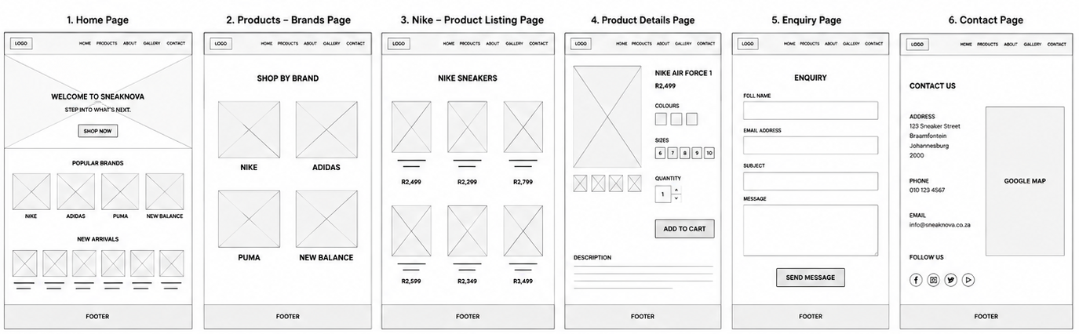
Continuation of Design and User Experience
Hierarchy chart

Technical Requirements
Programming Languages
- HTML
- CSS
- JavaScript
Hosting
- HostAfrica
Domain Name
www.sneaknova.co.za

Timeline and Milestones
Week 1 – Research and Proposal
Week 2 – Content Planning
Week 3 – HTML Development
Week 4 – Add images and videos
Week 5 – CSS Styling and JavaScript Features
Week 6 – Testing and Bug Fixing
Week 7 – Final Submission

Budget
The estimated cost for developing the initial SneakNova website is approximately R2,500–R5,000. This estimate includes:
- Basic website development
- Domain registration
- Basic web hosting
- Basic branding and website design
- Initial website maintenance
The initial version will focus on the core website structure and product presentation. As SneakNova develops, additional costs may be incurred when advanced functionality is introduced, such as CSS styling, JavaScript interactivity, database integration, online payment functionality, shopping cart functionality and other advanced e-commerce features.

References
12 Essential e-commerce website features for your South African online store in 2025. (2025). In Procompare.co.za. https://www.procompare.co.za/articles/web-design/ecommerce-website-features-south-africa

Adidas. (2022). Adidas official website | Adidas South Africa. In Adidas.co.za. https://www.adidas.co.za/

Almeida, A. (2023, July 31). 21 Essential elements of an effective event website: A comprehensive guide. InEvent. https://inevent.com/blog/others/21-essential-elements-of-an-effective-event-website-a-comprehensive-guide.html

dB, L. (2022, August 30). Email hosting South Africa – mail & workspace for SA businesses. Hostafrica. https://hostafrica.co.za/email-hosting/?utm_source=bing&utm_medium=cpc&utm_campaign=domains&utm_adgroup=register&gclid=&msclkid=2ef8b43071361151a994de4485813be8

Google. (2016). In Google.co.za. https://www.google.co.za

Nike (South Africa). (2026). Nike.Com. https://www.nike.com/za/?msockid=22e6cfa8576864ef2fdadd7a56956552

Pinterest. (2019). Pinterest. In Pinterest. Pinterest. https://za.pinterest.com/

Shutterstock. (2025). Stock photos, pictures & royalty free videos | shutterstock. In Shutterstock. https://www.shutterstock.com/

South Africa’s premium footwear outlet | shelflife. (n.d.). In www.shelflife.co.za. Retrieved 6 August 2026, from https://www.shelflife.co.za/

Unsplash. (2025). Beautiful free images & pictures. In Unsplash. Unsplash. https://unsplash.com/

w3Schools. (2019). JavaScript tutorial. In W3schools. https://www.w3schools.com/js/default.asp

What features do you need for a online sneaker store website - bing. (2024a). Bing. https://www.bing.com/search?q=what+features+do+you+need+for+a+online+sneaker+store+website&cvid=dcb974dc4b2c4c838822d0d770b09c02&gs_lcrp=EgRlZGdlKgYIABBFGDkyBggAEEUYOdIBCTIzMjQ2ajBqNKgCCLACAQ&FORM=ANAB01&adppc=EDGEINJP&PC=HCTS

What is CSS? - Learn web development | MDN. (2024b). In MDN Web Docs. https://developer.mozilla.org/en-US/docs/Learn_web_development/Core/Styling_basics/What_is_CSS

